BCM Bible Study – March 15/16, 2023
Galatians 1: The True Gospel
The letter of Galatians was written by Paul (1:1) to several of the churches that he would have helped to establish within the province of Galatia during his first missionary journey (Acts 12:25-14:25). It is thought to have been written in approximately 48 AD, which would make it Paul’s earliest letter we have.

Galatians was written to help correct the false teachings of the Judaizers who had infiltrated the area and suggested that the Old Testament Law still needed to be followed for faith in the Gospel. One of Paul’s primary goals in this letter is to show the supremacy of Jesus.

Read Galatians 1:1-5
- What do you make of Paul’s introduction here?
  - Why is it important that Paul was sent by God?
- Galatia was one of the provinces of the Roman Empire and was a region that Paul visited potentially only a year or so earlier (Acts 14:1-20). This is the same area that Timothy, who would later join Paul on mission, was from (Acts 16:1-5).
  - How significant does that make this letter’s purpose?
- How does this greeting anticipate the issues that Paul is going to address? (Revisit the book’s themes/topic in the intro).
  - One of the first things tackled in the letter is Paul’s authority, which is alluded to here and was likely something that the false teachers in Galatia were attacking.
  - For instance: Jesus’ resurrection is mentioned in this book only in verse 1! Why might Paul bring this up here and only here?
  - “Paul alludes to [how]... God has inaugurated a new age in salvation history, a situation that changes everything!” (Moo)

Read Galatians 1:6-10
- The only other letter written by Paul without a thanksgiving section in this spot is Titus. Read Romans 1:8-10 & 1 Corinthians 1:4-9 for an example of what this thanksgiving might look like.
  - How would you describe the tone of thanksgiving in Romans or 1 Corinthians?
  - Now compare that with the tone of verses 6-10 to the Galatian churches. Why might Paul have excluded such a thing for the Galatians?
- Who is the one who called them in v.6?
  - “The one who called is God the Father. But particularly significant is Paul’s addition: that God has called them “to live in the grace of Christ.” (Moo)
  - Paul’s emotion and choice of word here indicates such a deep care for the Galatians. What would having similar care for others in our relationships look like?
  - How does that care impact people knowing the truth of the Gospel?
Read Acts 15:1-3, 22-29
- What is this different gospel and where did it come from?
  - What things might people try to add to the Gospel today?
  - Where are you likely to add/subtract from the Gospel personally?
- Based on Paul’s words in v.8-9, how serious is getting the Gospel right?
  - Read Genesis 3:14-15, 4:10-12, 9:25
  - What does it mean to be cursed by God? How does that apply to false teachers?
- Why might Paul add v.10 here in such an abrupt fashion?
  - What are ways that we can seek to answer this question for ourselves?
  - How can we ensure that we are living for God and not people?

Read Galatians 1:11-24
- Why is it so significant that the Gospel Paul is preaching is not of human origin?
  - How does this reminder about the Gospel’s nature encourage your faith?
- What value does Paul gain in his appeal from telling the Galatians about his life like this?
  - “The way he [Paul] writes this narrative of his conversion and travels is best explained if he is defending against charges that the agitators have made about him.” (Moo)
  - Why might Paul mention his history with Judaism in this biography?
  - How effective would you say that Paul’s defense of himself is so far?
- What does it say that the churches in v.21-24 were able to praise God for Paul?
  - When are you able to rejoice in others and in God’s using them and when is it hard for you?
  - Take the twelve disciples for instance, who were there with Jesus from the beginning and yet bickered with one another to be greatest. Perhaps by that point, the Holy Spirit had grown them past it, but it might have been hard to see someone who persecuted the Church so viciously go on to do such great things for Christ.
- What might need to happen in your heart/faith so you can boast of God’s work in your life?

How might God have viewed Paul throughout his life? How might we have a more accurate view of ourselves before God?

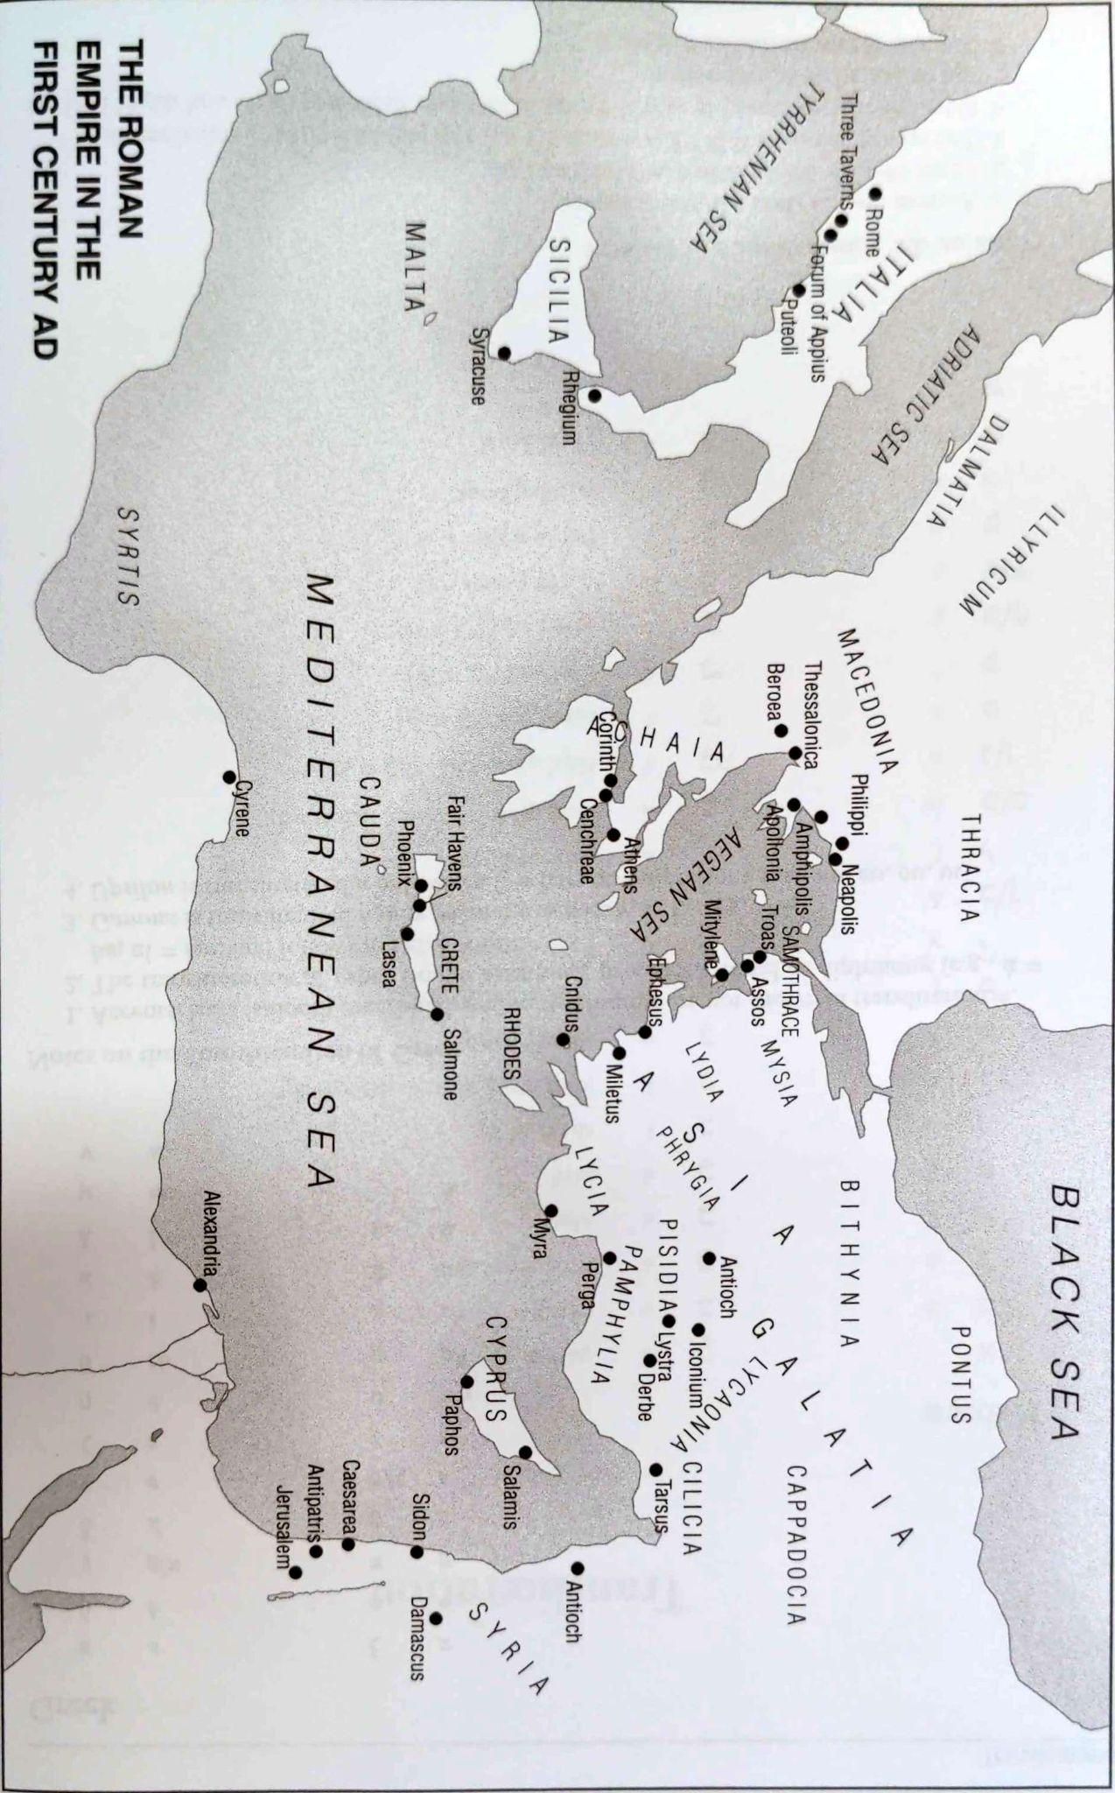
(white is land in this picture)

Galatians and Acts chronologically aligned/cross-referenced
Galatians | Acts
Persecution of the church (1:13-14) | Persecution of the church (9:1-2)
Conversion (1:15-16a)  Trip to Arabia (1:17a)  Return to Damascus (1:17b) | Conversion (9:3-19a)  Ministry in Damascus (9:19b-25)
“After three years”:  A visit to Jerusalem during which Paul “got to know” Cephas and met only Cephas and James among the apostles(1:18-20)  Ministry in Syria and Cilicia (1:21-24) | Visit to Jerusalem (9:26-29)
Return to Tarsus (9:30)
Ministry in Antioch (11:26)
Visit to Jerusalem to convey famine aid (11:27-30)
First missionary journey (12:25-14:25)
Cyrus
Pisidian Antioch
Iconium
Lystra
Derbe
Stay in Antioch (14:26-28)
“After fourteen years”:  A visit to Jerusalem to consult with the “pillar” apostles over the nature of the gospel and spheres of ministry (2:1-10)  Conflict in Antioch (2:11-14) | Visit to Jerusalem for consultation about whether Gentile Christians need to be circumcised and to obey the law of Moses (15:1-29)  Ministry in Antioch (15:35)  Second missionary journey (15:26-18:21)  Syria & Cilicia  Derbe  Lystra

